Ideation Phase Brainstorm & Idea Prioritization

|  |  |
| --- | --- |
| Date | 19 October 2022 |
| Team ID | PNT2022TMID23664 |
| Project Name | A Novel Method for Handwritten Digit Recognition System |
| Maximum Marks | 4 Marks |

**Brainstorm & Idea Prioritization Template:**

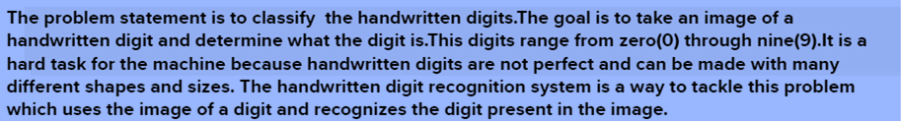

Brainstorm, Idea Listing

1.sangavi.M 2. SindhuDharshini.R

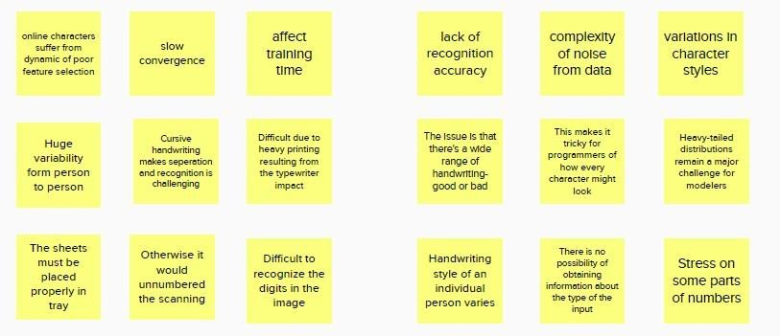

3. Sushmitha.S.R 4.Tiyaladha.G

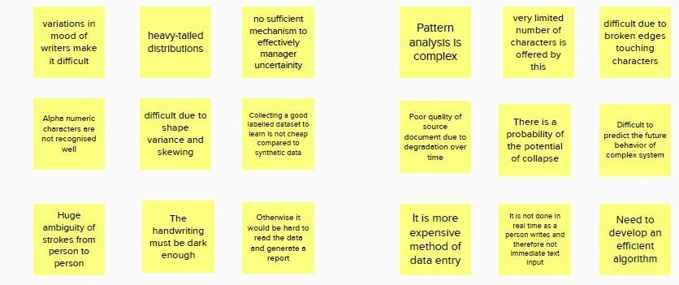

Idea Prioritization Grouping:

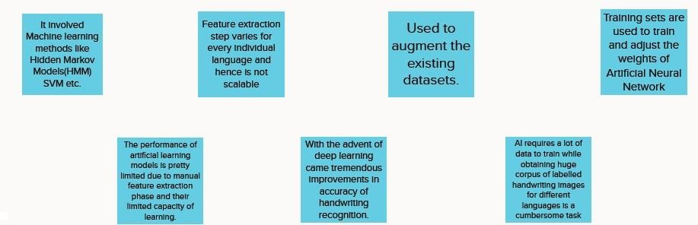

Priority Ideas:

